hwk5_financial

Dingxian CAO

library(quantmod)

getSymbols("AAPL", from= "2005-10-31" , to = "2015-10-31")

## [1] "AAPL"

AAPL<-Ad(AAPL)

## daily log returns

r<-diff(log(AAPL))[-1]

## a

t.test(r)#

##   
## One Sample t-test  
##   
## data: r  
## t = 2.5223, df = 2516, p-value = 0.01172  
## alternative hypothesis: true mean is not equal to 0  
## 95 percent confidence interval:  
## 0.0002425603 0.0019370020  
## sample estimates:  
## mean of x   
## 0.001089781

reject null hypothesis which means the mean is not zero

## b

Box.test(r, type="Ljung-Box" , lag = 10) #

##   
## Box-Ljung test  
##   
## data: r  
## X-squared = 15.3188, df = 10, p-value = 0.1209

accept null hypothesis which means the series has no serial correlation ## c

par(mfrow=c(1,2))  
acf(r)  
pacf(r,lag.max = 50)

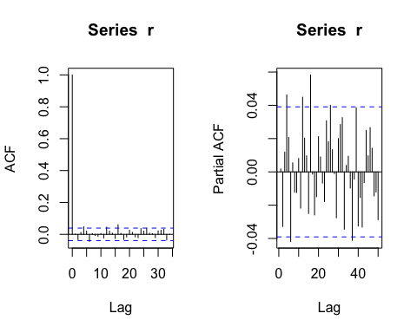

library(forecast)

mean.model<-auto.arima(r)  
summary(mean.model)#arma(3,2)

## Series: r   
## ARIMA(3,0,2) with non-zero mean   
##   
## Coefficients:  
## ar1 ar2 ar3 ma1 ma2 intercept  
## 0.2629 -0.9355 0.0218 -0.2620 0.9139 0.0011  
## s.e. 0.0694 0.0372 0.0214 0.0668 0.0457 0.0004  
##   
## sigma^2 estimated as 0.0004669: log likelihood=6080.51  
## AIC=-12147.03 AICc=-12146.98 BIC=-12106.21  
##   
## Training set error measures:  
## ME RMSE MAE MPE MAPE MASE  
## Training set 9.829081e-06 0.02160715 0.0152951 NaN Inf 0.6998237  
## ACF1  
## Training set 0.000451625

resid2<- (residuals(mean.model))^2  
acf(resid2)  
pacf(resid2, lag=20, main="")

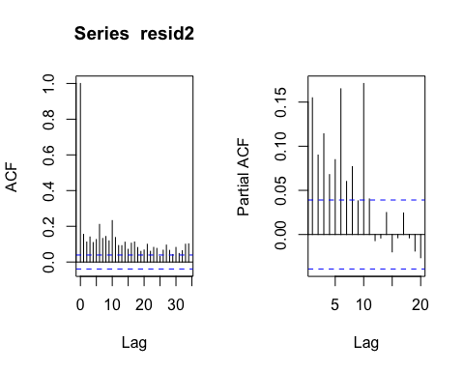

Box.test(resid2, type = "Ljung-Box" , fitdf = 5, lag = 10)# there exits arch effect

##   
## Box-Ljung test  
##   
## data: resid2  
## X-squared = 590.9262, df = 5, p-value < 2.2e-16

length(resid2)

## [1] 2517

y<-resid2[12:2517]  
x<-cbind(resid2[11:2516],resid2[10:2515],resid2[9:2514],resid2[8:2513]  
 ,resid2[7:2512],resid2[6:2511],resid2[5:2510], resid2[4:2509],resid2[3:2508]  
 , resid2[2:2507], resid2[1:2506])  
summary(lm(y~x))#

##   
## Call:  
## lm(formula = y ~ x)  
##   
## Residuals:  
## Min 1Q Median 3Q Max   
## -0.003733 -0.000330 -0.000197 0.000034 0.036664   
##   
## Coefficients:  
## Estimate Std. Error t value Pr(>|t|)   
## (Intercept) 1.511e-04 3.101e-05 4.872 1.18e-06 ***  
## x1 7.211e-02 2.001e-02 3.604 0.000319 ***  
## x2 1.882e-02 1.978e-02 0.952 0.341402   
## x3 5.774e-02 1.978e-02 2.920 0.003535 **   
## x4 9.490e-03 1.977e-02 0.480 0.631215   
## x5 3.949e-02 1.975e-02 1.999 0.045726 *   
## x6 1.443e-01 1.956e-02 7.377 2.19e-13 ***  
## x7 3.943e-02 1.975e-02 1.996 0.046032 *   
## x8 6.563e-02 1.977e-02 3.320 0.000914 ***  
## x9 2.267e-02 1.978e-02 1.146 0.251742   
## x10 1.679e-01 1.978e-02 8.492 < 2e-16 ***  
## x11 4.026e-02 2.001e-02 2.012 0.044322 *   
## ---  
## Signif. codes: 0 '***' 0.001 '**' 0.01 '*' 0.05 '.' 0.1 ' ' 1  
##   
## Residual standard error: 0.001234 on 2494 degrees of freedom  
## Multiple R-squared: 0.1196, Adjusted R-squared: 0.1157   
## F-statistic: 30.8 on 11 and 2494 DF, p-value: < 2.2e-16

F-statistics is 30.8, the null hypothesis of no arch effect is rejected

## d

library(rugarch)

## Loading required package: parallel

par(mfrow=c(1,1))  
plot(density(r),add = T, lty= 1 )

curve(dnorm(x, mean(r), sd(r)), from = -0.2, to = 0.15, lty= 2,add = T)  
legend("topright", lty=c(1,2), c("sample", "Norm"))

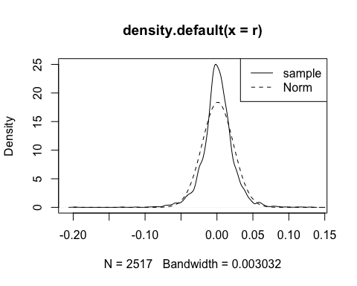

spec1=ugarchspec(  
 variance.model = list(model = "sGARCH", garchOrder = c(1, 1)),  
 mean.model = list(armaOrder = c(3, 2)), distribution.model = "norm") # specify model  
  
m1=ugarchfit(r,spec=spec1) # fit model  
std.resid<-m1@fit$z  
qqnorm(std.resid)   
qqline(std.resid)

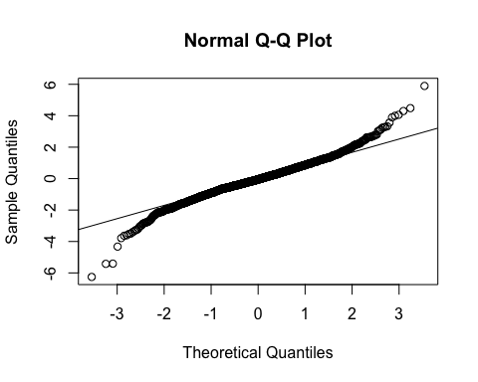

m1# the model

##   
## *---------------------------------*  
## * GARCH Model Fit *  
## *---------------------------------*  
##   
## Conditional Variance Dynamics   
## -----------------------------------  
## GARCH Model : sGARCH(1,1)  
## Mean Model : ARFIMA(3,0,2)  
## Distribution : norm   
##   
## Optimal Parameters  
## ------------------------------------  
## Estimate Std. Error t value Pr(>|t|)  
## mu 0.001911 0.000367 5.2016 0.00000  
## ar1 1.235313 0.035992 34.3215 0.00000  
## ar2 -0.987138 0.026309 -37.5209 0.00000  
## ar3 0.032012 0.021787 1.4693 0.14174  
## ma1 -1.215679 0.028872 -42.1058 0.00000  
## ma2 0.965921 0.003272 295.2077 0.00000  
## omega 0.000012 0.000001 10.8331 0.00000  
## alpha1 0.087511 0.004809 18.1971 0.00000  
## beta1 0.888285 0.008899 99.8159 0.00000  
##   
## Robust Standard Errors:  
## Estimate Std. Error t value Pr(>|t|)  
## mu 0.001911 0.000389 4.9165 0.000001  
## ar1 1.235313 0.050898 24.2702 0.000000  
## ar2 -0.987138 0.024393 -40.4673 0.000000  
## ar3 0.032012 0.021956 1.4580 0.144841  
## ma1 -1.215679 0.046417 -26.1906 0.000000  
## ma2 0.965921 0.004191 230.4740 0.000000  
## omega 0.000012 0.000003 4.5947 0.000004  
## alpha1 0.087511 0.009957 8.7889 0.000000  
## beta1 0.888285 0.011636 76.3374 0.000000  
##   
## LogLikelihood : 6338.024   
##   
## Information Criteria  
## ------------------------------------  
##   
## Akaike -5.0290  
## Bayes -5.0082  
## Shibata -5.0290  
## Hannan-Quinn -5.0215  
##   
## Weighted Ljung-Box Test on Standardized Residuals  
## ------------------------------------  
## statistic p-value  
## Lag[1] 0.08124 0.7756  
## Lag[2*(p+q)+(p+q)-1][14] 6.18343 0.9898  
## Lag[4*(p+q)+(p+q)-1][24] 11.05638 0.6901  
## d.o.f=5  
## H0 : No serial correlation  
##   
## Weighted Ljung-Box Test on Standardized Squared Residuals  
## ------------------------------------  
## statistic p-value  
## Lag[1] 0.005208 0.9425  
## Lag[2*(p+q)+(p+q)-1][5] 1.349858 0.7767  
## Lag[4*(p+q)+(p+q)-1][9] 2.626582 0.8186  
## d.o.f=2  
##   
## Weighted ARCH LM Tests  
## ------------------------------------  
## Statistic Shape Scale P-Value  
## ARCH Lag[3] 0.3126 0.500 2.000 0.5761  
## ARCH Lag[5] 2.5236 1.440 1.667 0.3667  
## ARCH Lag[7] 2.6936 2.315 1.543 0.5732  
##   
## Nyblom stability test  
## ------------------------------------  
## Joint Statistic: 7.7499  
## Individual Statistics:   
## mu 0.3674  
## ar1 0.1465  
## ar2 0.1275  
## ar3 0.4910  
## ma1 0.1949  
## ma2 0.1192  
## omega 2.0589  
## alpha1 0.5768  
## beta1 0.6592  
##   
## Asymptotic Critical Values (10% 5% 1%)  
## Joint Statistic: 2.1 2.32 2.82  
## Individual Statistic: 0.35 0.47 0.75  
##   
## Sign Bias Test  
## ------------------------------------  
## t-value prob sig  
## Sign Bias 0.9021 0.36709   
## Negative Sign Bias 1.4486 0.14757   
## Positive Sign Bias 0.4846 0.62799   
## Joint Effect 9.2095 0.02663 **  
##   
##   
## Adjusted Pearson Goodness-of-Fit Test:  
## ------------------------------------  
## group statistic p-value(g-1)  
## 1 20 82.40 7.137e-10  
## 2 30 80.18 1.092e-06  
## 3 40 105.60 4.747e-08  
## 4 50 103.84 8.170e-06  
##   
##   
## Elapsed time : 1.094827

Box.test(std.resid, lag=10, type = "Ljung-Box", fitdf = 5)

##   
## Box-Ljung test  
##   
## data: std.resid  
## X-squared = 9.1852, df = 5, p-value = 0.1019

Box.test(std.resid^2, lag=10, type = "Ljung-Box", fitdf = 5)

##   
## Box-Ljung test  
##   
## data: std.resid^2  
## X-squared = 5.9887, df = 5, p-value = 0.3073

acf(std.resid^2)# the model is adequate

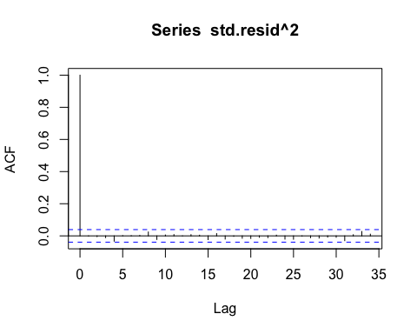

## e

spec2=ugarchspec(  
 variance.model = list(model = "sGARCH", garchOrder = c(1, 1)),  
 mean.model = list(armaOrder = c(3, 2)), distribution.model = "std") # specify model  
m2=ugarchfit(r,spec=spec2) # fit model  
  
m2# the model

##   
## *---------------------------------*  
## * GARCH Model Fit *  
## *---------------------------------*  
##   
## Conditional Variance Dynamics   
## -----------------------------------  
## GARCH Model : sGARCH(1,1)  
## Mean Model : ARFIMA(3,0,2)  
## Distribution : std   
##   
## Optimal Parameters  
## ------------------------------------  
## Estimate Std. Error t value Pr(>|t|)  
## mu 0.001592 0.000336 4.7307 0.000002  
## ar1 1.222765 0.015926 76.7783 0.000000  
## ar2 -0.983297 0.024126 -40.7570 0.000000  
## ar3 0.023210 0.019402 1.1963 0.231596  
## ma1 -1.213835 0.006300 -192.6759 0.000000  
## ma2 0.970486 0.000942 1029.9024 0.000000  
## omega 0.000006 0.000003 1.7122 0.086859  
## alpha1 0.066101 0.012054 5.4839 0.000000  
## beta1 0.922470 0.014764 62.4805 0.000000  
## shape 5.476156 0.589812 9.2846 0.000000  
##   
## Robust Standard Errors:  
## Estimate Std. Error t value Pr(>|t|)  
## mu 0.001592 0.000341 4.66920 0.000003  
## ar1 1.222765 0.019664 62.18288 0.000000  
## ar2 -0.983297 0.022232 -44.22982 0.000000  
## ar3 0.023210 0.018011 1.28863 0.197525  
## ma1 -1.213835 0.010290 -117.96193 0.000000  
## ma2 0.970486 0.001091 889.71766 0.000000  
## omega 0.000006 0.000007 0.83365 0.404478  
## alpha1 0.066101 0.015828 4.17633 0.000030  
## beta1 0.922470 0.023110 39.91690 0.000000  
## shape 5.476156 0.658387 8.31754 0.000000  
##   
## LogLikelihood : 6428.096   
##   
## Information Criteria  
## ------------------------------------  
##   
## Akaike -5.0998  
## Bayes -5.0766  
## Shibata -5.0998  
## Hannan-Quinn -5.0914  
##   
## Weighted Ljung-Box Test on Standardized Residuals  
## ------------------------------------  
## statistic p-value  
## Lag[1] 0.4233 0.5153  
## Lag[2*(p+q)+(p+q)-1][14] 5.9785 0.9967  
## Lag[4*(p+q)+(p+q)-1][24] 10.8823 0.7149  
## d.o.f=5  
## H0 : No serial correlation  
##   
## Weighted Ljung-Box Test on Standardized Squared Residuals  
## ------------------------------------  
## statistic p-value  
## Lag[1] 0.294 0.5877  
## Lag[2*(p+q)+(p+q)-1][5] 1.107 0.8351  
## Lag[4*(p+q)+(p+q)-1][9] 2.240 0.8745  
## d.o.f=2  
##   
## Weighted ARCH LM Tests  
## ------------------------------------  
## Statistic Shape Scale P-Value  
## ARCH Lag[3] 0.03292 0.500 2.000 0.8560  
## ARCH Lag[5] 1.61217 1.440 1.667 0.5633  
## ARCH Lag[7] 1.76623 2.315 1.543 0.7666  
##   
## Nyblom stability test  
## ------------------------------------  
## Joint Statistic: 2.9201  
## Individual Statistics:   
## mu 0.19223  
## ar1 0.27608  
## ar2 0.05915  
## ar3 0.11869  
## ma1 0.28095  
## ma2 0.04125  
## omega 0.49995  
## alpha1 1.28965  
## beta1 1.21910  
## shape 1.26054  
##   
## Asymptotic Critical Values (10% 5% 1%)  
## Joint Statistic: 2.29 2.54 3.05  
## Individual Statistic: 0.35 0.47 0.75  
##   
## Sign Bias Test  
## ------------------------------------  
## t-value prob sig  
## Sign Bias 0.8535 0.39345   
## Negative Sign Bias 1.8607 0.06291 *  
## Positive Sign Bias 0.3601 0.71880   
## Joint Effect 11.0810 0.01130 **  
##   
##   
## Adjusted Pearson Goodness-of-Fit Test:  
## ------------------------------------  
## group statistic p-value(g-1)  
## 1 20 20.01 0.3938  
## 2 30 34.36 0.2264  
## 3 40 41.24 0.3731  
## 4 50 45.44 0.6184  
##   
##   
## Elapsed time : 1.055861

std.resid<-m2@fit$z  
Box.test(std.resid, lag=10, type = "Ljung-Box", fitdf = 5)

##   
## Box-Ljung test  
##   
## data: std.resid  
## X-squared = 8.6818, df = 5, p-value = 0.1224

Box.test(std.resid^2, lag=10, type = "Ljung-Box", fitdf = 5)

##   
## Box-Ljung test  
##   
## data: std.resid^2  
## X-squared = 5.5582, df = 5, p-value = 0.3516

acf(std.resid^2)# the model is adequate

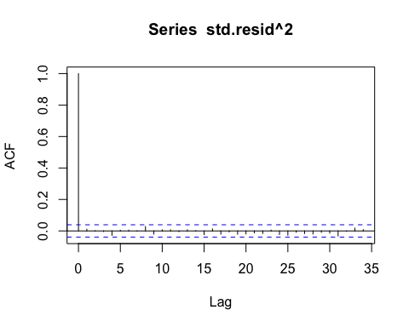

## f

plot(sigma(m2))

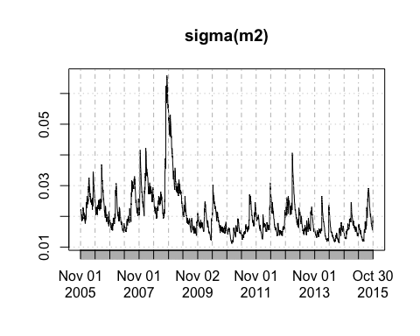

## g

forecast=ugarchforecast(m2, data=NULL, n.ahead = 5, n.roll= 0, out.sample = 0)  
forecast

##   
## *------------------------------------*  
## * GARCH Model Forecast *  
## *------------------------------------*  
## Model: sGARCH  
## Horizon: 5  
## Roll Steps: 0  
## Out of Sample: 0  
##   
## 0-roll forecast [T0=2015-10-30]:  
## Series Sigma  
## T+1 0.0011525 0.01902  
## T+2 0.0006568 0.01907  
## T+3 0.0006443 0.01912  
## T+4 0.0013424 0.01917  
## T+5 0.0021967 0.01921

## h

spec3=ugarchspec(  
 variance.model = list(model = "iGARCH", garchOrder = c(1, 1)),  
 mean.model = list(armaOrder = c(3, 2)), distribution.model = "std") # specify model  
m3=ugarchfit(r,spec=spec3) # fit model  
  
m3# the model

##   
## *---------------------------------*  
## * GARCH Model Fit *  
## *---------------------------------*  
##   
## Conditional Variance Dynamics   
## -----------------------------------  
## GARCH Model : iGARCH(1,1)  
## Mean Model : ARFIMA(3,0,2)  
## Distribution : std   
##   
## Optimal Parameters  
## ------------------------------------  
## Estimate Std. Error t value Pr(>|t|)  
## mu 0.001584 0.000315 5.02377 0.000001  
## ar1 1.221103 0.016718 73.04291 0.000000  
## ar2 -0.981507 0.023620 -41.55387 0.000000  
## ar3 0.022498 0.019023 1.18266 0.236946  
## ma1 -1.213054 0.023464 -51.69782 0.000000  
## ma2 0.969588 0.001783 543.91406 0.000000  
## omega 0.000004 0.000009 0.38847 0.697672  
## alpha1 0.071375 0.054680 1.30533 0.191781  
## beta1 0.928625 NA NA NA  
## shape 4.994197 0.206171 24.22357 0.000000  
##   
## Robust Standard Errors:  
## Estimate Std. Error t value Pr(>|t|)  
## mu 0.001584 0.000954 1.659896 0.096935  
## ar1 1.221103 0.176020 6.937308 0.000000  
## ar2 -0.981507 0.039376 -24.926594 0.000000  
## ar3 0.022498 0.032047 0.702028 0.482662  
## ma1 -1.213054 0.167622 -7.236862 0.000000  
## ma2 0.969588 0.010569 91.736836 0.000000  
## omega 0.000004 0.000078 0.047314 0.962263  
## alpha1 0.071375 0.454284 0.157115 0.875154  
## beta1 0.928625 NA NA NA  
## shape 4.994197 3.324889 1.502064 0.133081  
##   
## LogLikelihood : 6426.291   
##   
## Information Criteria  
## ------------------------------------  
##   
## Akaike -5.0992  
## Bayes -5.0783  
## Shibata -5.0992  
## Hannan-Quinn -5.0916  
##   
## Weighted Ljung-Box Test on Standardized Residuals  
## ------------------------------------  
## statistic p-value  
## Lag[1] 0.4987 0.4801  
## Lag[2*(p+q)+(p+q)-1][14] 5.9220 0.9976  
## Lag[4*(p+q)+(p+q)-1][24] 10.7838 0.7287  
## d.o.f=5  
## H0 : No serial correlation  
##   
## Weighted Ljung-Box Test on Standardized Squared Residuals  
## ------------------------------------  
## statistic p-value  
## Lag[1] 0.3171 0.5733  
## Lag[2*(p+q)+(p+q)-1][5] 1.1046 0.8356  
## Lag[4*(p+q)+(p+q)-1][9] 2.0733 0.8961  
## d.o.f=2  
##   
## Weighted ARCH LM Tests  
## ------------------------------------  
## Statistic Shape Scale P-Value  
## ARCH Lag[3] 0.05902 0.500 2.000 0.8081  
## ARCH Lag[5] 1.55560 1.440 1.667 0.5778  
## ARCH Lag[7] 1.68353 2.315 1.543 0.7839  
##   
## Nyblom stability test  
## ------------------------------------  
## Joint Statistic: 5.2869  
## Individual Statistics:   
## mu 0.18982  
## ar1 0.28386  
## ar2 0.06376  
## ar3 0.11122  
## ma1 0.29269  
## ma2 0.04312  
## omega 0.76705  
## alpha1 0.23104  
## shape 0.92928  
##   
## Asymptotic Critical Values (10% 5% 1%)  
## Joint Statistic: 2.1 2.32 2.82  
## Individual Statistic: 0.35 0.47 0.75  
##   
## Sign Bias Test  
## ------------------------------------  
## t-value prob sig  
## Sign Bias 0.8550 0.39264   
## Negative Sign Bias 1.5967 0.11046   
## Positive Sign Bias 0.5919 0.55395   
## Joint Effect 10.3641 0.01571 **  
##   
##   
## Adjusted Pearson Goodness-of-Fit Test:  
## ------------------------------------  
## group statistic p-value(g-1)  
## 1 20 24.99 0.1610  
## 2 30 37.29 0.1389  
## 3 40 50.45 0.1035  
## 4 50 48.81 0.4807  
##   
##   
## Elapsed time : 0.804373

std.resid<-m3@fit$z  
Box.test(std.resid, lag=10, type = "Ljung-Box", fitdf = 5)

##   
## Box-Ljung test  
##   
## data: std.resid  
## X-squared = 8.5714, df = 5, p-value = 0.1274

Box.test(std.resid^2, lag=10, type = "Ljung-Box", fitdf = 5)

##   
## Box-Ljung test  
##   
## data: std.resid^2  
## X-squared = 4.8416, df = 5, p-value = 0.4355

acf(std.resid^2)# the model is adequate

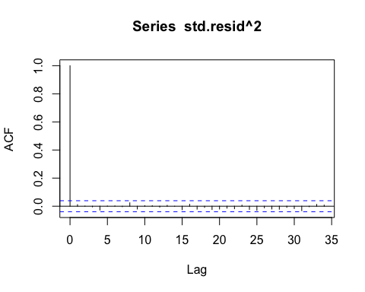

## i

spec4=ugarchspec(  
 variance.model = list(model = "fGARCH", submodel="TGARCH", garchOrder = c(1, 1)),  
 mean.model = list(armaOrder = c(3, 2)), distribution.model = "std") # specify model  
m4=ugarchfit(r,spec=spec4) # fit model  
  
m4# the model

##   
## *---------------------------------*  
## * GARCH Model Fit *  
## *---------------------------------*  
##   
## Conditional Variance Dynamics   
## -----------------------------------  
## GARCH Model : fGARCH(1,1)  
## fGARCH Sub-Model : TGARCH  
## Mean Model : ARFIMA(3,0,2)  
## Distribution : std   
##   
## Optimal Parameters  
## ------------------------------------  
## Estimate Std. Error t value Pr(>|t|)  
## mu 0.001383 0.000347 3.9851 0.000067  
## ar1 1.231947 0.084023 14.6621 0.000000  
## ar2 -0.987183 0.050451 -19.5670 0.000000  
## ar3 0.032414 0.034293 0.9452 0.344554  
## ma1 -1.213709 0.041444 -29.2854 0.000000  
## ma2 0.964723 0.005096 189.3042 0.000000  
## omega 0.000604 0.000161 3.7578 0.000171  
## alpha1 0.093424 0.015110 6.1828 0.000000  
## beta1 0.899205 0.016804 53.5121 0.000000  
## eta11 0.504236 0.096706 5.2141 0.000000  
## shape 6.031037 0.701781 8.5939 0.000000  
##   
## Robust Standard Errors:  
## Estimate Std. Error t value Pr(>|t|)  
## mu 0.001383 0.000442 3.12736 0.001764  
## ar1 1.231947 0.267748 4.60114 0.000004  
## ar2 -0.987183 0.152060 -6.49204 0.000000  
## ar3 0.032414 0.100015 0.32409 0.745868  
## ma1 -1.213709 0.127531 -9.51701 0.000000  
## ma2 0.964723 0.014253 67.68338 0.000000  
## omega 0.000604 0.000201 3.00379 0.002666  
## alpha1 0.093424 0.025052 3.72926 0.000192  
## beta1 0.899205 0.026971 33.33963 0.000000  
## eta11 0.504236 0.092589 5.44594 0.000000  
## shape 6.031037 0.835516 7.21834 0.000000  
##   
## LogLikelihood : 6449.277   
##   
## Information Criteria  
## ------------------------------------  
##   
## Akaike -5.1158  
## Bayes -5.0904  
## Shibata -5.1159  
## Hannan-Quinn -5.1066  
##   
## Weighted Ljung-Box Test on Standardized Residuals  
## ------------------------------------  
## statistic p-value  
## Lag[1] 0.8899 0.3455  
## Lag[2*(p+q)+(p+q)-1][14] 6.5326 0.9523  
## Lag[4*(p+q)+(p+q)-1][24] 11.7399 0.5878  
## d.o.f=5  
## H0 : No serial correlation  
##   
## Weighted Ljung-Box Test on Standardized Squared Residuals  
## ------------------------------------  
## statistic p-value  
## Lag[1] 0.001002 0.9747  
## Lag[2*(p+q)+(p+q)-1][5] 1.210595 0.8105  
## Lag[4*(p+q)+(p+q)-1][9] 2.130016 0.8889  
## d.o.f=2  
##   
## Weighted ARCH LM Tests  
## ------------------------------------  
## Statistic Shape Scale P-Value  
## ARCH Lag[3] 0.4293 0.500 2.000 0.5123  
## ARCH Lag[5] 1.9681 1.440 1.667 0.4783  
## ARCH Lag[7] 2.1452 2.315 1.543 0.6866  
##   
## Nyblom stability test  
## ------------------------------------  
## Joint Statistic: 3.7354  
## Individual Statistics:   
## mu 0.87903  
## ar1 0.11422  
## ar2 0.04545  
## ar3 0.12704  
## ma1 0.14052  
## ma2 0.04249  
## omega 1.96082  
## alpha1 2.14890  
## beta1 2.21949  
## eta11 0.09455  
## shape 1.66164  
##   
## Asymptotic Critical Values (10% 5% 1%)  
## Joint Statistic: 2.49 2.75 3.27  
## Individual Statistic: 0.35 0.47 0.75  
##   
## Sign Bias Test  
## ------------------------------------  
## t-value prob sig  
## Sign Bias 0.2578 0.7966   
## Negative Sign Bias 0.4900 0.6242   
## Positive Sign Bias 0.4054 0.6852   
## Joint Effect 1.4001 0.7055   
##   
##   
## Adjusted Pearson Goodness-of-Fit Test:  
## ------------------------------------  
## group statistic p-value(g-1)  
## 1 20 19.60 0.4191  
## 2 30 30.97 0.3667  
## 3 40 46.48 0.1914  
## 4 50 45.08 0.6329  
##   
##   
## Elapsed time : 2.587099

std.resid<-m4@fit$z  
Box.test(std.resid, lag=10, type = "Ljung-Box", fitdf = 5)

##   
## Box-Ljung test  
##   
## data: std.resid  
## X-squared = 9.9825, df = 5, p-value = 0.07573

Box.test(std.resid^2, lag=10, type = "Ljung-Box", fitdf = 5)

##   
## Box-Ljung test  
##   
## data: std.resid^2  
## X-squared = 4.9427, df = 5, p-value = 0.4229

acf(std.resid^2)# the model is adequate

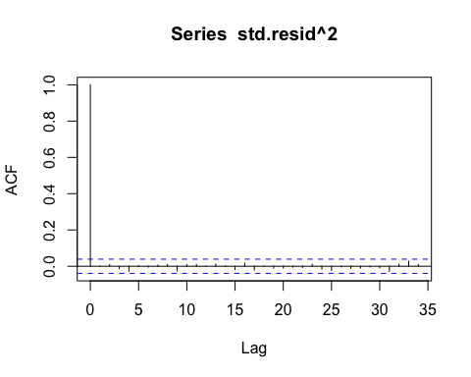

## j

spec5 <- ugarchspec(   
 variance.model=list(model="sGARCH", garchOrder=c(1,1)),  
 mean.model=list(armaOrder=c(3,2), include.mean=T, archm=T, archpow=2) ,   
 distribution.model="std")   
m5=ugarchfit(r,spec=spec5) # fit model  
  
m5 # the model

##   
## *---------------------------------*  
## * GARCH Model Fit *  
## *---------------------------------*  
##   
## Conditional Variance Dynamics   
## -----------------------------------  
## GARCH Model : sGARCH(1,1)  
## Mean Model : ARFIMA(3,0,2)  
## Distribution : std   
##   
## Optimal Parameters  
## ------------------------------------  
## Estimate Std. Error t value Pr(>|t|)  
## mu 0.001833 0.000613 2.99057 0.002785  
## ar1 0.211122 0.018050 11.69618 0.000000  
## ar2 -0.999564 0.003379 -295.79212 0.000000  
## ar3 0.018713 0.017368 1.07743 0.281289  
## ma1 -0.192951 0.004880 -39.54060 0.000000  
## ma2 0.993129 0.000520 1909.15840 0.000000  
## archm -0.729364 1.569364 -0.46475 0.642110  
## omega 0.000006 0.000004 1.46301 0.143464  
## alpha1 0.063390 0.013622 4.65341 0.000003  
## beta1 0.925711 0.017662 52.41192 0.000000  
## shape 5.441661 0.585986 9.28633 0.000000  
##   
## Robust Standard Errors:  
## Estimate Std. Error t value Pr(>|t|)  
## mu 0.001833 0.000607 3.02028 0.002525  
## ar1 0.211122 0.016526 12.77481 0.000000  
## ar2 -0.999564 0.002919 -342.40887 0.000000  
## ar3 0.018713 0.015512 1.20632 0.227695  
## ma1 -0.192951 0.004327 -44.59525 0.000000  
## ma2 0.993129 0.000646 1537.81194 0.000000  
## archm -0.729364 1.481220 -0.49241 0.622431  
## omega 0.000006 0.000009 0.62829 0.529815  
## alpha1 0.063390 0.021701 2.92102 0.003489  
## beta1 0.925711 0.034168 27.09295 0.000000  
## shape 5.441661 0.669206 8.13152 0.000000  
##   
## LogLikelihood : 6427.315   
##   
## Information Criteria  
## ------------------------------------  
##   
## Akaike -5.0984  
## Bayes -5.0729  
## Shibata -5.0984  
## Hannan-Quinn -5.0891  
##   
## Weighted Ljung-Box Test on Standardized Residuals  
## ------------------------------------  
## statistic p-value  
## Lag[1] 0.09532 0.7575  
## Lag[2*(p+q)+(p+q)-1][14] 7.67794 0.3737  
## Lag[4*(p+q)+(p+q)-1][24] 12.49833 0.4721  
## d.o.f=5  
## H0 : No serial correlation  
##   
## Weighted Ljung-Box Test on Standardized Squared Residuals  
## ------------------------------------  
## statistic p-value  
## Lag[1] 0.3705 0.5427  
## Lag[2*(p+q)+(p+q)-1][5] 1.2103 0.8105  
## Lag[4*(p+q)+(p+q)-1][9] 2.5537 0.8297  
## d.o.f=2  
##   
## Weighted ARCH LM Tests  
## ------------------------------------  
## Statistic Shape Scale P-Value  
## ARCH Lag[3] 0.05072 0.500 2.000 0.8218  
## ARCH Lag[5] 1.62873 1.440 1.667 0.5591  
## ARCH Lag[7] 1.78326 2.315 1.543 0.7631  
##   
## Nyblom stability test  
## ------------------------------------  
## Joint Statistic: 3.0927  
## Individual Statistics:   
## mu 0.24180  
## ar1 0.03612  
## ar2 0.05078  
## ar3 0.04160  
## ma1 0.05580  
## ma2 0.10295  
## archm 0.07928  
## omega 0.37845  
## alpha1 1.20076  
## beta1 1.08808  
## shape 1.08753  
##   
## Asymptotic Critical Values (10% 5% 1%)  
## Joint Statistic: 2.49 2.75 3.27  
## Individual Statistic: 0.35 0.47 0.75  
##   
## Sign Bias Test  
## ------------------------------------  
## t-value prob sig  
## Sign Bias 0.8652 0.387008   
## Negative Sign Bias 1.9097 0.056282 *  
## Positive Sign Bias 0.3658 0.714525   
## Joint Effect 11.5570 0.009065 ***  
##   
##   
## Adjusted Pearson Goodness-of-Fit Test:  
## ------------------------------------  
## group statistic p-value(g-1)  
## 1 20 17.66 0.5452  
## 2 30 32.83 0.2845  
## 3 40 41.78 0.3511  
## 4 50 48.73 0.4839  
##   
##   
## Elapsed time : 2.632857

std.resid<-m5@fit$z  
Box.test(std.resid, lag=10, type = "Ljung-Box", fitdf = 5)

##   
## Box-Ljung test  
##   
## data: std.resid  
## X-squared = 13.6766, df = 5, p-value = 0.0178

Box.test(std.resid^2, lag=10, type = "Ljung-Box", fitdf = 5)

##   
## Box-Ljung test  
##   
## data: std.resid^2  
## X-squared = 6.351, df = 5, p-value = 0.2735

acf(std.resid^2)# the model is adequate

